# How to setup Cloud9 environment

## Create account

1. Open URL in your web browser: <https://c9.io/>
2. Setup your account

Version with credit card: follow the instruction and complete all steps.

Eventually a credit card detail will be asked to finalize the account but won’t be charged.

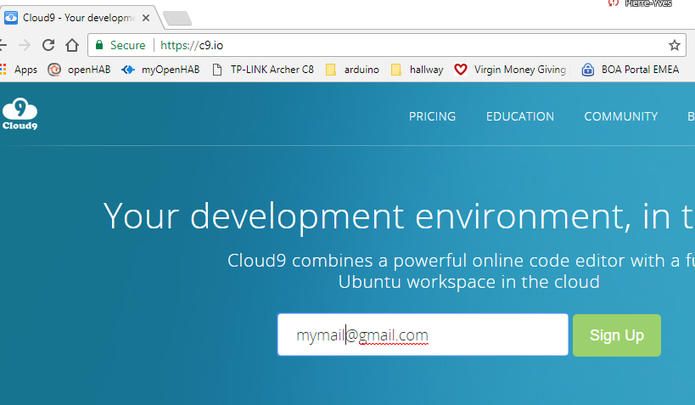

Alternative 1 : codeanywhere.com

Alternative 2 : teacher account

## Create your project

1. Open url <https://c9.io/dashboard.html>

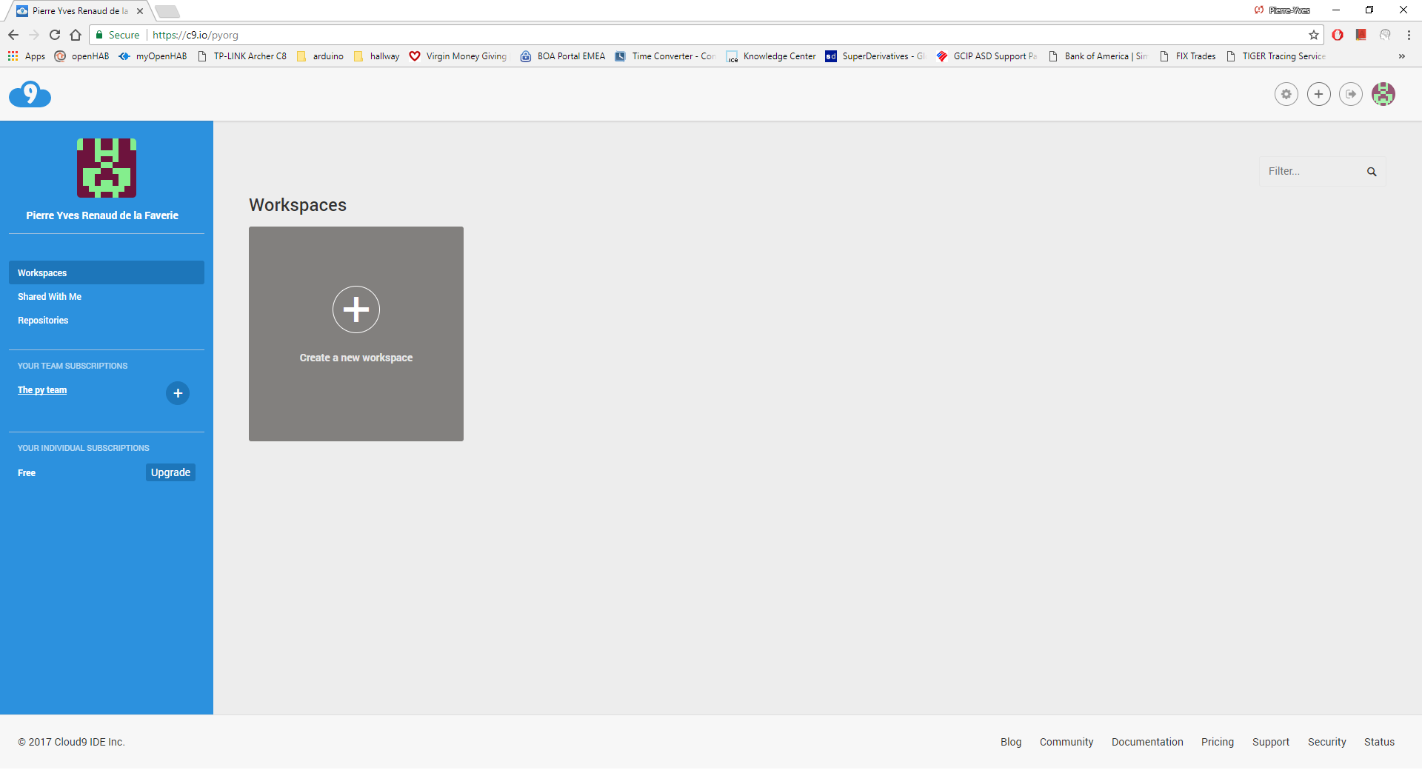

1. Create New project
   1. Enter Workspace name without space and all lower case that will identify your team
   2. In the Team drop down, don’t select a team by choosing “Don’t set a team for this workspace”
   3. In the Hosted workspace section, choose “Public”
   4. In the clone from Git, enter exactly <https://github.com/BAMLCodeJam/codejam>
   5. Finally choose the Python project and Create the workspace

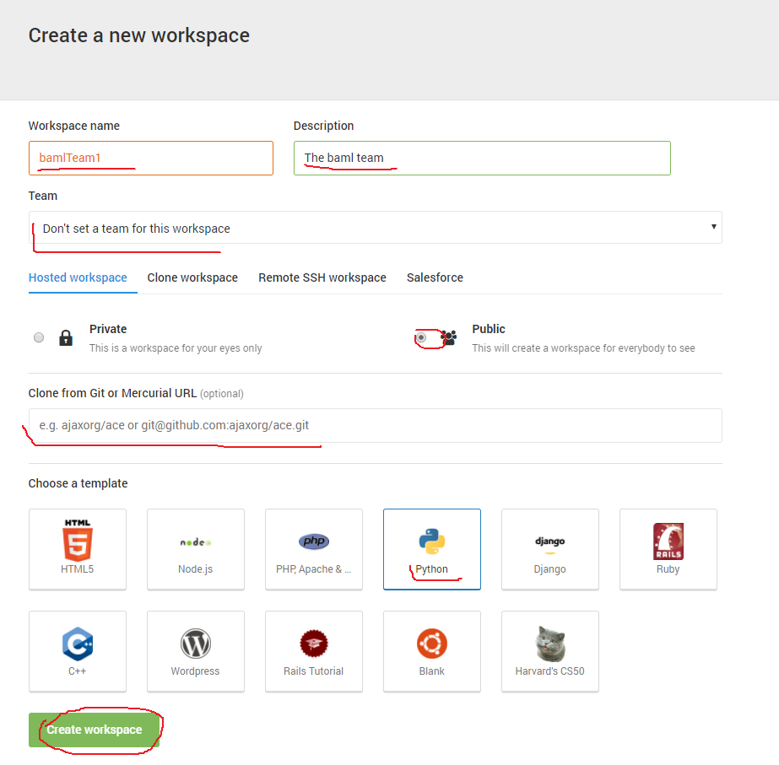

## Adding necessary libraries

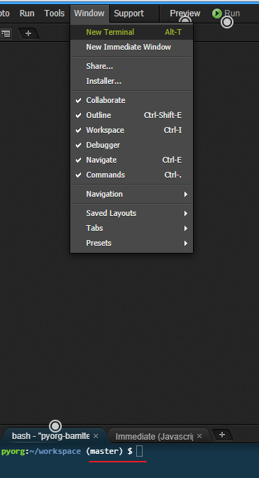

Once the workspace is created (it might take a few minutes), In the shell (Window > New Terminal), enter sequentially the following command lines:

*>sudo easy_install Flask*

*>sudo easy_install tweepy*

*>sudo easy_install watson-developer-cloud*

*>sudo easy_install uber_rides*

*>sudo easy_install aftership*

## Running the project

On the main.py file right click and on the context menu select “run”.

If no error is thrown in the shell, to view the web app:

Option 1: Get the url from the shell and copy in your browser. In my screen copy the url is <https://test-project-baml-pyorg.c9users.io/>. Anyone can access this url and you will be able to use it for your presentation.

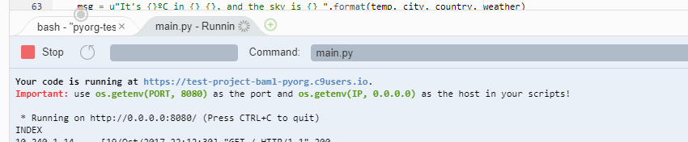

Option 2: click on “Preview” on the right of app menus. A new window will open with the content of the website

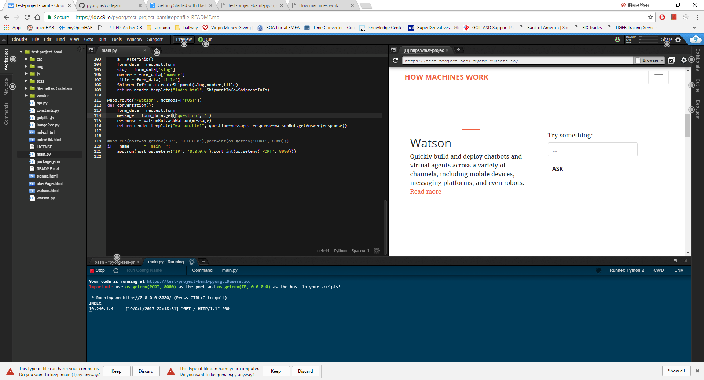

## It is your turn now! Have fun.

## Annexe: Github modification

Youtube tutorial: <https://www.youtube.com/watch?v=zBWHKO2v07E&ab_channel=VenkatP>

1. Activate change
   1. Menu Cloud9>Preference
   2. Section experimental> activate the “Change panel” option
   3. Refresh cloud 9 webpage

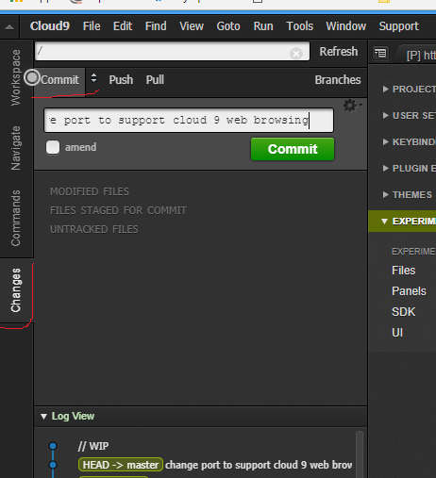

1. In the Change panel
   1. Commit with comment
   2. In the shell >git push
   3. Enter credential